

**Blood Pressure estimation based on PPG using neural network**

Project Submitted By: Dorin Alon & Shirili Shelef

Project Supervisors: Ron Teichner & Dr. Danny Eitan

**Contents:**

1. Abstract //shirili
2. Introduction:
   1. Motivation //shirili
   2. Project goal //dorin
   3. Medical background //dorin - *(write something about the database?)*
3. The chosen network
   1. Architecture//shirili -only explenation on LSTM
4. Project flow
   1. Synthetic signals //(in short) //dorin – fix to what we really did
   2. Choosing the input signals to the net //shirili – choosing PPG because it’s similar to BP
   3. Block diagram//shirili
5. Results:
   1. Creation and optimization of the net //dorin
   2. Training on a single patient and predicting BP of the same patient//shirili
   3. Training on a single patient and predicting BP of different patients//shirili
6. Conclusion:
   1. Discussion *//algorithm and problems-* *normalization data , clips position, various train*
   2. Future works
7. Appendix:
   1. Pictures from synthetic signals
   2. Output – test on the same patient
   3. Output – test on another patient
   4. Code and user instructions
8. References

**1. Abstract**

Blood pressure (BP) is a significant vital that is monitored for every patient in intensive care. BP could indicate patients' cardiovascular status. Nowadays, BP is measured throughout an invasive manner - catheter directly into an artery.

This form of measurement is not convenient for the patient and could lead an infection. Photopletysmogram (PPG) is a signal measured in a non-invasive manner – a clips on the patient's finger. In this project, we will suggest a way to estimate BP using neural network (NN) type LSTM with PPG as it's only input.

**2. Introduction**

**2.1 - motivation:**

Critically ill patients are monitored continuously with vital physiologic signals. The medical team need to be in control over the patient signals, specifically blood pressure (BP). The way to measure this vital is a catheter into an artery, this way the signal can be presented continuously on a monitor. Another way to measure BP is with a cuff on a patient's limb, but the measurement is taken periodically, and the result is inaccurate enough and not continuously. Therefore, patient BP is monitored in an invasive way, which can lead to an infection and thrombosis (clot).

There is no direct formula which connect BP values to other vitals that are measured in non-invasive ways, such as electrocardiogram (ECG), respiratory impedance (RI), and PPG. Nevertheless, the connection between the signals exists, so artificial intelligence was required to learn a patient and figure out the connection. In this project we will present the neural network we used to estimate BP using PPG.

*הסבר על חשיבותו של לחץ הדם עבור מטופלים, למה אין דרך אחרת חוץ מהקטטר, ולמה בחרנו ברשת נוירונים שתלמד את המטופל.*

**2.2 – project goal:**

As mentioned in the motivation above, a patient's blood pressure is measured in a very invasive way. The goal of this project is to estimate a patient's blood pressure by means of deep learning methods, functioning on non-invasive continuously measured vitals, such as ECG, RI and PPG. By that, it is possible to avoid BP measuring at all, or to measure it for a short period of time. The estimation is required to be quite accurate, and predict BP elevation or descent, since it can indicate a patient's status, and alert the medical crew before an emergency.

**2.3 – medical background**

* hospital A,

* not normalized signals

* BP conversion formula

* explain on every signals and figures of the signals

* sampling rates

**3. The chosen network**

Long Short-term memory (LSTM) is an artificial Recurrent neural network (RNN) architecture that can process an entire sequence of data, and not a single point. This quality of memory of the past is necessary for learning a patient's behavior. The downside of LSTM is the need of powerful process unit, so we used the GPU of the lab.

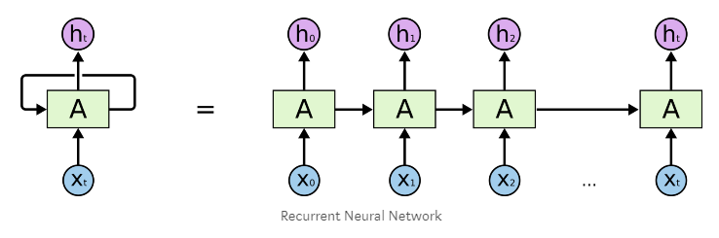

**3.1 - Architecture:**

At first we tried a straight forward approach – 1 big vector of 10 minute train set. We performed many trials for the network features – we changed the number of layers, number of hidden layers, amount of iterations, and step size. Some produced better results than other, but the whole process of train took a lot of time – more than 1 hour for 10 minute train set.

In order to take advantage of the qualities of GPU and shorten the train process - we tried a parallel approach.

After several trials, we decided to perform the train procedure with 2**16 samples, which are equivalent to approximately 9 minutes. We divided this train set to batches of 16 seconds, which means 32 batches. This way we reached improvement by 32 time than without batches (without batches means the whole train set in one vector). From one hand, using GPU can reach 2500 train iterations in 10 minutes, from the other hand, the memory of the LSTM is only 16 seconds.

The final parameters:

|  |  |  |  |
| --- | --- | --- | --- |
| **Layers** | **Hidden size** | **Step size** | **Iterations** |
| 2 | 12 | 1e-3 | 2500-3500 |

**4. Project flow**

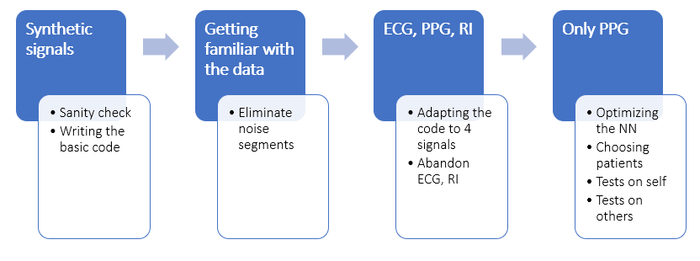

**4.1 – synthetic signals:**

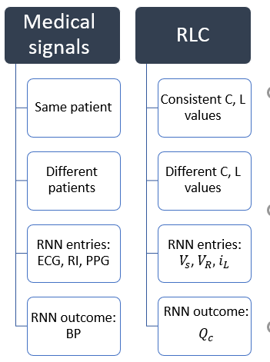In order to ensure that our neural network is working, we performed a sanity check. We created four types of synthetic signals that simulates an electric circuit. Since it is a well-known problem, it has a scientific solution that is composed of a differential equation. The four signals are source voltage, resistor voltage, inductor current and capacitor charge. We especially chose the synthetic signals so that they will be somehow equivalent to our medical signals, and this experiment will simulate the medical situation. Bellow, the analogy between the synthetic and the medical signals:   
  
C- capacitor's capacity

L-

the relation between the four signals is as shown:

insert the equation

bellow, our network prediction of the capacitor’s charge given different input signals:

insert results

**4.2 - Choosing the input signals to the net:**

By looking at our data, the most similar vital to BP is PPG – they are sampled in the same ratio, they seems to have similar cyclic *(periodic מחזורי)*  behavior, and medically it makes sense to research their correlation – every heart beat delivers blood saturated with oxygen, so a change in blood pressure is correlated with change in oxygen level in it (which is exactly what PPG indicates).

Moreover, we performed several trials for estimation BP based on all the signals in the database: PPG, RI, ECG. Those trials were made before the batches optimization that was done for the NN, which means 3 input to the NN, each contains a long vector of train data. As a result, the NN could not estimate BP in a good way – the estimation was pretty bad. For comparison, the same NN with the same features that got only PPG for estimated pretty well the BP of the patient.

All of the above led us to use the PPG vital as the only input to the NN.

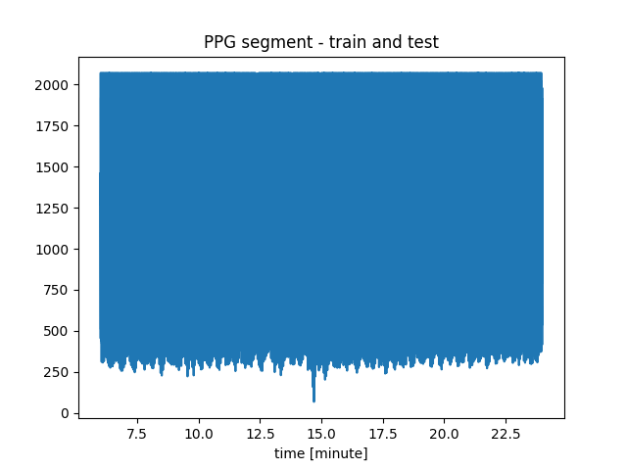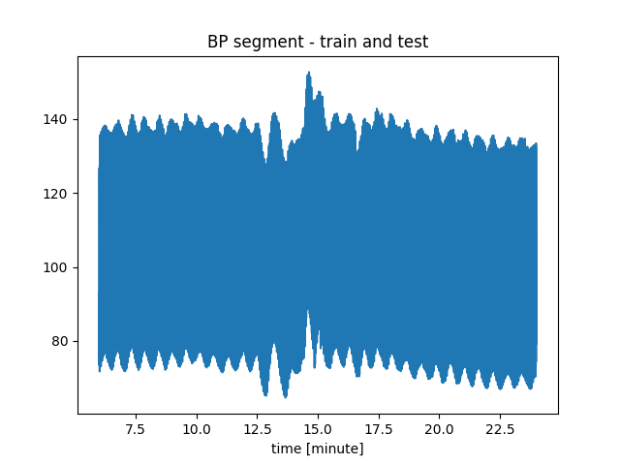We took patient 2728529-6532 (which has various BP and doesn’t have noisy segments) to perform this experiment.

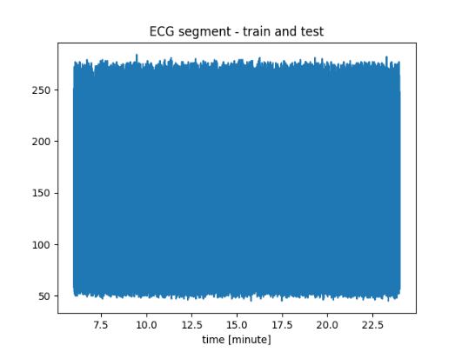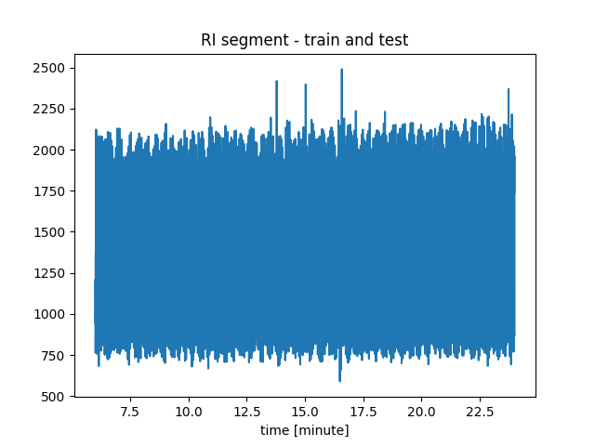

In order of use all 4 signals, we converted RFG and RI to the same sample rate as BP, PPG- 125 Hz. The scaling in the figure below is essential for NN inputs, and we discuss about scaling and normalizing our data in chapter _____

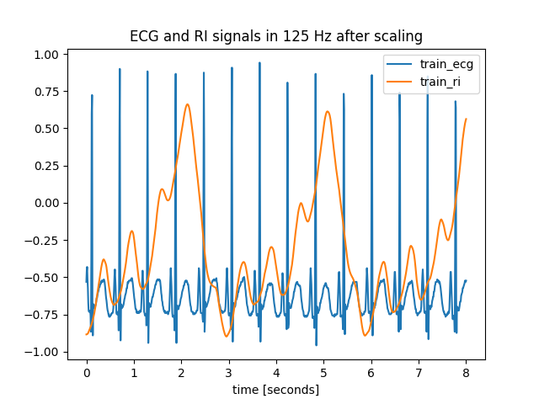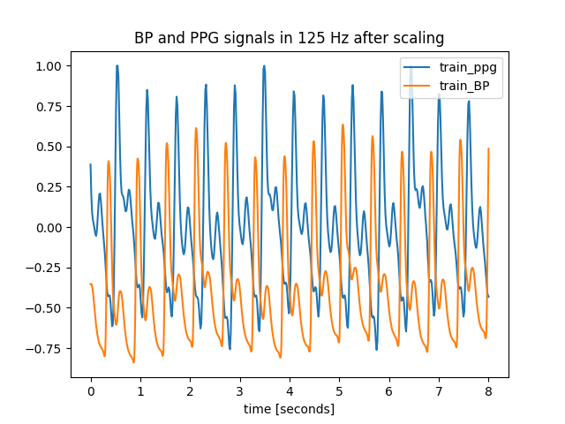

Division for train and test segments:



**test**

**train**

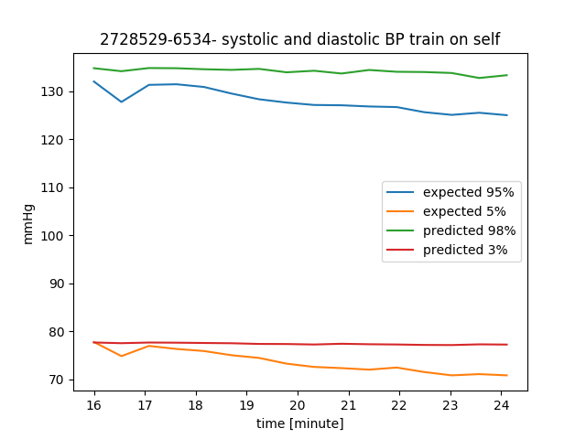Throughout a 9 minutes train that included all the signals above as inputs to the NN, we performed a test over the next 9 minutes:

At this point, comparing the estimation we got based only on PPG signal, we realized that ECG and RI don’t contribute to the learning process of the NN.

We tried several trainings with PPG, that led us to optimizing the NN and realize it's limitations. The main limitation was choosing a patient from the data base. We chose a patient's signals that stood in several criterial:

- BP segments has to be various enough (include increasing and decreasing of BP).

- both BP and PPG segments should be proper measured and without noise. Our data base is raw and the signals come from critically-ill patients, so the data can contains exceptions and picks that can confuse our NN. The noise can come(לנבוע ) from movement of the patient, treatment from the medical staff or measurement noise from the monitor or the recording unit. //לשפר את הניסוח

- we tried to choose a patient that was recorded long enough (every segment is 40 minutes approximately), so we could test the trained NN for different periods of time after the train period //2 hours after the train, 5 hours, 22 hours….

**4.3 – block diagram:**

In the following diagrams we will show the signal flow from the database to the BP estimation:

**Train and test on the same patient:**

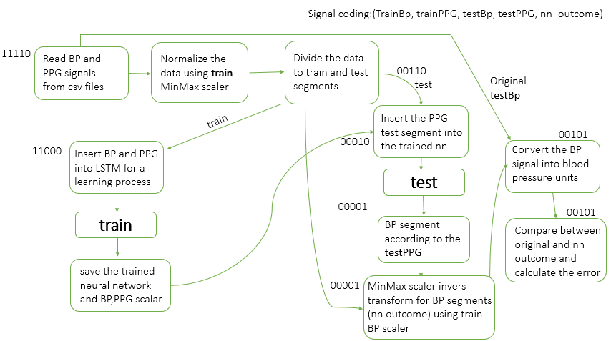

**Train on one patient and test on another:**

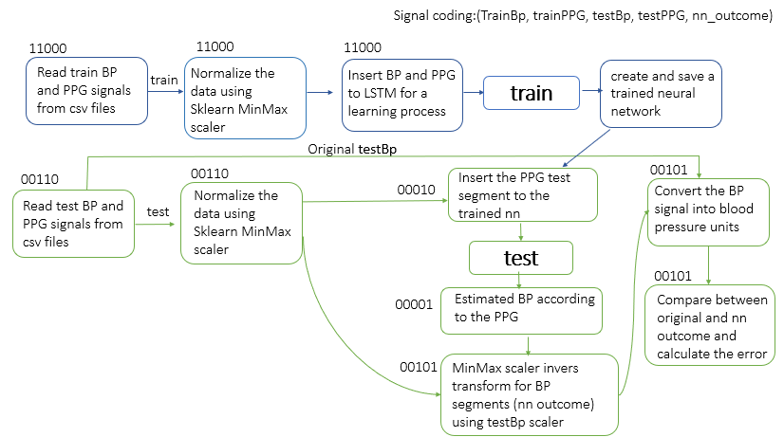

The output graph we will look to evaluate our NN contains a graph for systolic value (high line) and diastolic value (lower line). We used an average over percentage value for every 30 seconds. The 95% of the BP signal should represent systolic value and 5% of the BP signal should represent the diastolic value. The NN output and the expected BP (the expected signal is drawn from the data base) is on the same graph so we can compare them.

**5. Results**

**5.1 - Creation and optimization of the net:**  
hidden layers and all- try different values and show results.

GPU batches- faster- explain why

**5.2 - Training on a single patient and predicting BP of the same patient**

We succeeded in learning a patient behavior and infer about future and past times (of the certain patient). We took a train set that was various enough, we made sure that the BP segment contained increasing and decreasing in BP values. The variation is important in the train segment because the NN can't produce values that it hasn’t seen in the train part.

With 10 minute of train segment, the NN succeed in estimating future BP based on PPG segment.

For example, we trained on patient 2123847-10616 for 9 minutes:

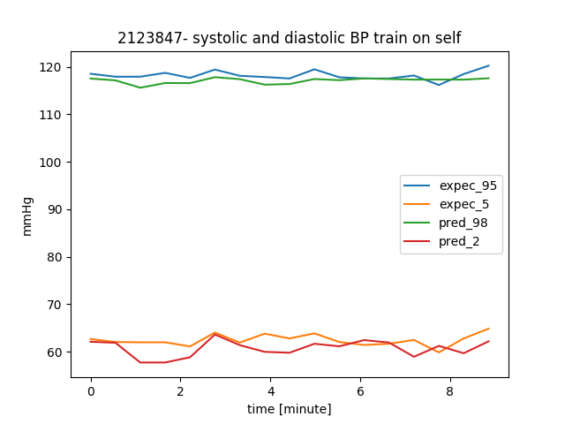

Test after 2.5 hours:

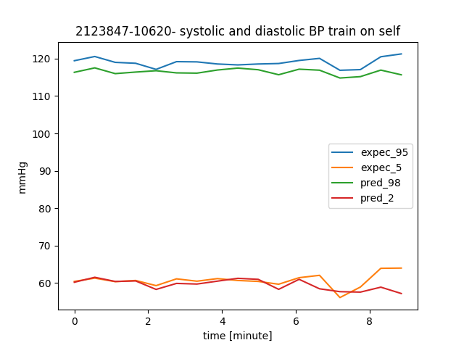

Test after 5.5 hours:

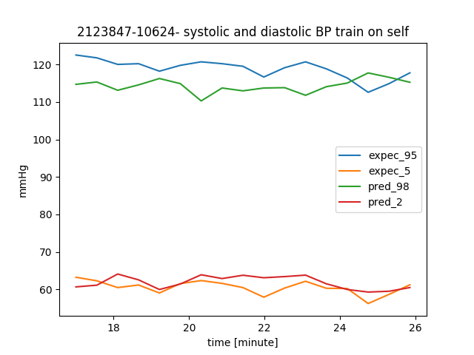

Test after 11 hours:

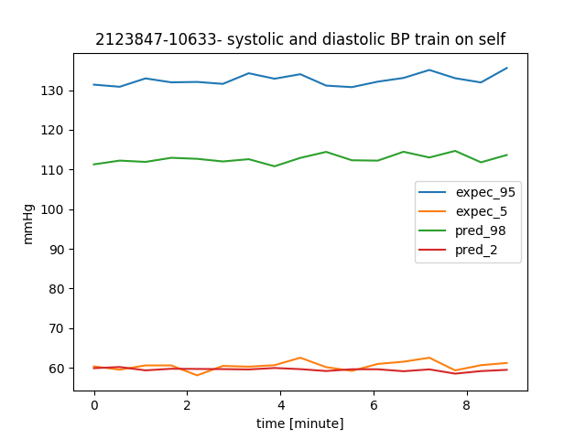

We can see that sometimes the NN estimates BP values pretty well in the next few hours after the train, and sometimes the estimation isn't that good. All of the results are detailed in the appendix.

We assume that the faults in the estimation are due to changes in PPG segment. The patient's physiology can change sometimes due to medications or medical condition. The change in PPG can also arise from the way the clips is suited on the patient's hand (figures in the appendix).

We discovered that the NN can estimate BP in the past – which means that we managed to learn a patient's physiology.

Train on 2728529-6534:

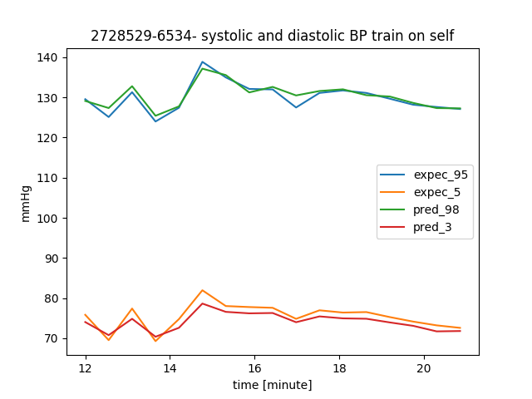

Test on a segment 27 minutes earlier (before the train):

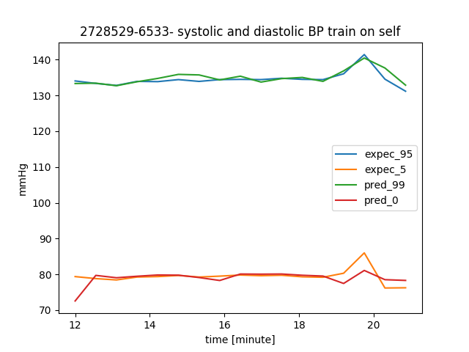

**5.3 - Training on a single patient and predicting BP of different patients**

We examined a NN that was trained on a certain patient (10 minute of a various segment) – perform an estimation for another patient. The data normalization has been done with the test segment.

We trained a NN for 9 minutes on 1887524-1978:

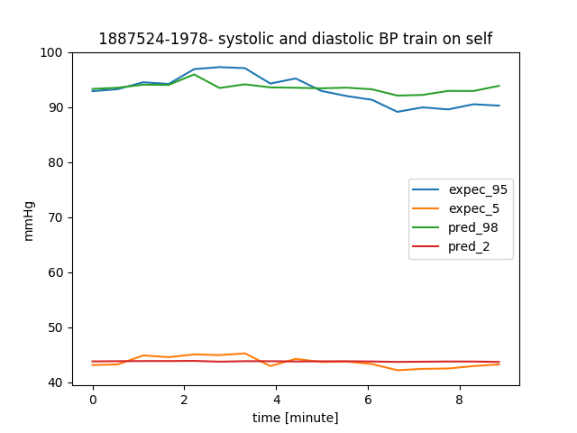

We performed a 9 minutes test on 2043726-9499:

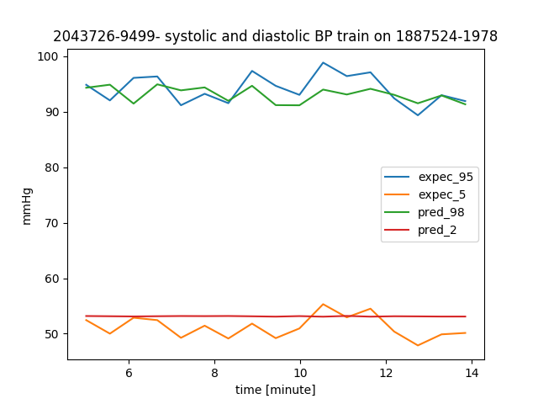

We can see that the estimation isn’t good – the net couldn’t estimate the diastolic at all. The systolic estimation has a certain delay in the estimation, and the values are not reaching the expected minimum and maximum.

We assume that bad estimation of the diastolic is because the NN was exposed in the train set to values in range 40-50, and here in the test patient there are values in range of 45-55. This outcome is reasonable, because the NN can't deliver values that it wasn’t exposed to during training. Moreover, we can see that the BP of the test patient is more dynamic in comparison of the train patient.

**6. Conclusion**

Learning a patient's behavior - this could spare the invasive measurement and rely on PPG measurement only.

//problems: - normalization, various data (and also the same range), changing PPG (could be clips, could be medications or physical condition of the patient)

algorithm:

future works:

**7. Appendix**